PROJECT

Assessment of Project
Mapped GAs | Bloom Taxonomy | Marks
GA6 | A2 | 20

Teacher Name: Miss Hina Rizwan Khan
Students Name | Registration #
Ramaisha Rehman | 73978
Eisha-Tir-Razia | 73973
Muhammad Suleman | 73885

Title: Customer Feedback System

Objective:
The main objective of Customer Feedback System is to create and develop a Customer Feedback System that allows customers to without difficulty submit their feedback, reviews and ratings about products or services. The system goals to support organization gather important customer opinions study satisfaction levels and develop service standard based on real user feedback.

Motivation:
You will learn skills that are critical in today's technologically advanced globe. Ranging from complex document formatting and automation using Word to expert analysis and programming skills you will learn the skills to handle problems effectively and efficiently in the real world. Topics including web design database management and analysis are all important areas of knowledge that will serve as significant skills for your career path ahead. Being engaged in the Customer Feedback System project challenges students to learn actual business requirements and the use of technological support for improving customer satisfaction and decision making.

Concept:
The Customer Feedback System is a web-based system that allows customers to submit feedback in the form of opinions suggestions and complaints. This system enables the storage of feedback in a database that can be analyzed. Administrators can view and interpret the feedback regarding the trends benefits and drawbacks of the services or products. The concept enhances improvement and development from the customer perspective.

Problem Statement:
Many businesses are faced with challenges when it comes to efficiently acquiring organizing as well as analyzing customer feedback. This often means that valuable customer feedback is overlooked or simply lost. The challenge here is to create an application capable of acquiring, organizing analyzing as well as providing customer feedback in an organized fashion.

Design / Ways & Means:

Introduction and Obligations:

- Friendly interface for customers
- Submits feedback electronically
- Admin interface to read and process comments
- Database to store customer responses

Choosing a Data Structure:

- Arrays or lists for storing temporary feedback
- Typically, for storing temporary
- Database tables for permanent storage
- The fields include customer name feedback comment rating score and date.
Basic Implementation:

- Building feedback from tools
- Data validation
- Storing Feedback Information Using Database
- There is an
Performance Testing and Analysis:

- Evaluating system response time
- Validating data for accuracy and optimizing storage
Optimization & Advanced Features:

- Search & filter feedback
- Graphical rating display
- Categorization of feedback
Extensions, Innovations:

- Email alerts
- Anonymous feedback option
- Mobile friendly interface

Analysis & Reporting /Answer:
The system was tested by compiling feedback from users. The data was analyzed through the use of reports to determine the level of customer satisfaction. It was determined that feedback is essential in identifying issues and improving services.

Lab Activity:

- Designing in feedback forms
- Handling database connectivity
- Testing of feedback submission and retrieval
- Handling basic reports

Deliverables:

Background/Theory:
Modern business largely implements customer feedback systems to measure consumer satisfaction and improve services. They depend on techniques of data collection storage and analysis.
Procedure/Methodology:
- Identification of system requirements
- Design feedback form
- Data storing now will be implemented.
- Test system functionality
- Analyzing collected data
Data Collection:
This involves gathering feedback information using online forms that consumers fill.
Flow Chart / Block Diagram:

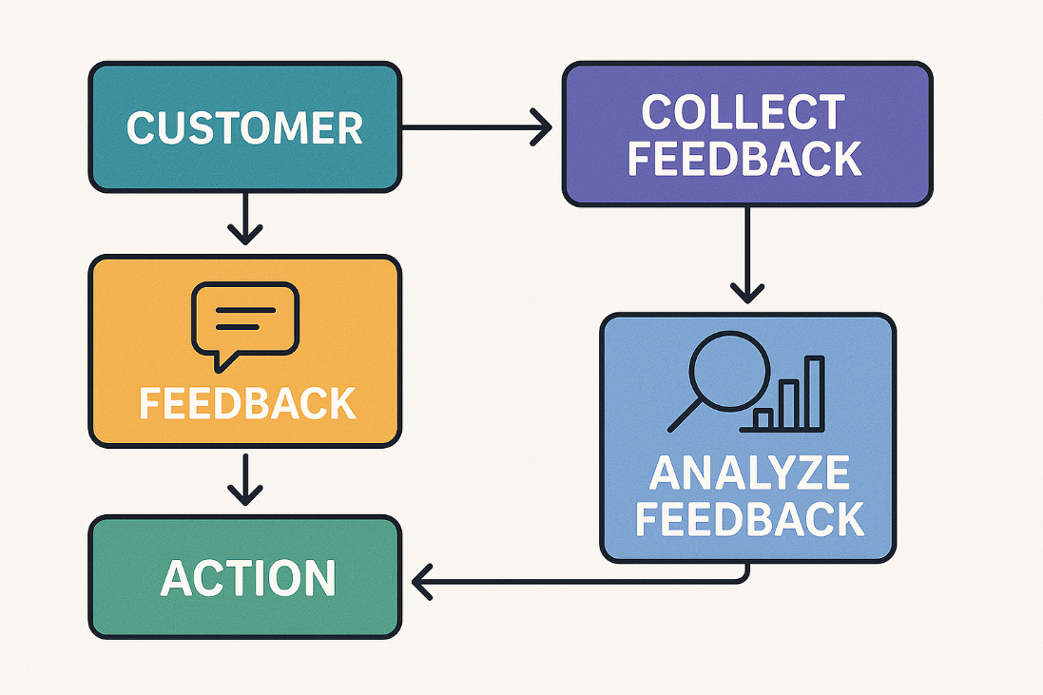
Analysis:
Data obtained is then analyzed through ratings and feedback to establish trends.
Results:
The tool is effective in gathering and structuring customer feedback.
Discussion on Results:
The analysis of results reveals increased efficiency in processing customer feedback and enhanced understanding of customer needs.
Conclusionary Statements:
A customer feedback system is an efficient way of dealing with customer opinions. A customer feedback system assists organizations in improving services enhancing customer satisfaction and making decisions.
Reference:
- Lecture Notes
- Websites about Customer Feedback Systems
- Software Engineering textbooks

